

# Mid Semester Project Progress Report on

**QRSAY – Digital Menu & Ordering Platform**

**Submitted in partial fulfillment for award of**

# BACHELOR OF TECHNOLOGY

**Degree In**

# COMPUTER SCIENCE & ENGINEERING

## 2023-24

**Under the Guidance of: Submitted By:**

Mrs. KP Jayant Chirag Singhal (200033010084)

Assistant Professor Ashutosh Maurya (200033010069)

### DEPARTMENT OF COMPUTER SCIENCE & ENGINEERING RAJ KUMAR GOEL INSTITUTE OF TECHNOLOGY

**5th K.M. STONE DELHI-MEERUT ROAD, GHAZIABAD**

**Affiliated to Dr. A.P.J. Abdul Kalam Technical University, Lucknow**

## November 2023

**Raj Kumar Goel Institute of Technology Ghaziabad**

***ISO 9001:2015 Certified***

***5th KM. STONE, DELHI-MEERUT ROAD, GHAZIABAD (U.P)-201003***

## Department of Computer Science & Engineering

**Project Progress Report**

1. Course : Bachelor of Technology
2. Semester : 7th
3. Branch : Computer Science & Engineering
4. Project Title : QRSAY – Digital Menu & Ordering Platform
5. Details of Students:

|  |  |  |  |  |
| --- | --- | --- | --- | --- |
| S. No. | Roll No. | Name | Role as | Signature |
| 1 | 200033010084 | Chirag Singhal | Team Leader |  |
| 2 | 200033010069 | Ashutosh Maurya | Team Member |  |
|  |  |  |  |  |
|  |  |  |  |  |

1. SUPERVISOR:

Mr. KP Jayant

### Remarks from Project Supervisor:

………………………………………………………………………………

………………………………………………………………………………

………………………………………………………………………………

**SYNOPSIS**

The "QRSAY" project is aimed at developing a user-friendly and efficient application that facilitates the process of ordering food online from various restaurants. With the increasing reliance on digital platforms for services, especially in the food industry, this app seeks to provide a seamless and convenient solution for customers to explore menus, place orders, and have their favorite dishes delivered or ready for pickup.

1. **Statement about the Problem: -**

In the restaurant industry, traditional operations face significant challenges. Lengthy service times, averaging 15-20 minutes per menu handling, result in operational inefficiencies. Furthermore, there has been driven the need for contactless dining solutions to ensure safety, demanding a fundamental shift in restaurant operations. Additionally, traditional menus pose various problems, including the difficulty in updating them, the lack of real-time updates, and the continued use of paper based menus, which are both environmentally unfriendly and prone to damage.

1. **Why is the particular topic chosen: -**

**Market Demand: -** The online food ordering and delivery industry has experienced exponential growth in recent years.

**Convenience: -**. Consumers are now more inclined to opt for contactless and digital solutions, including food ordering and delivery, to minimize physical interactions.

**Business Potential: -** For restaurants, embracing digital platforms is no longer an option but a necessity. The ability to reach a broader customer base through online channels is crucial for business survival and growth.

1. **Objective and scope of the project: -**

**Objective: -** The primary aim of this project is to create a user-centric Application with the option to have the delivery, take away, dining, scheduled dining or party booking with food advised according to the health and age using the artificial intelligence.

**Scope: -**

**1. User Registration and Authentication: -** Implement a secure and user-friendly registration and authentication system to enable users to create accounts, log in, and manage their profiles.

**2. Comprehensive Restaurant Listings with Menus: -** Develop a comprehensive database of restaurants with detailed menus, allowing users to browse a wide variety of food options.

**3. Streamlined Order Placement and Tracking: -** Enable users to easily place orders, customize their meals, and track the status of their orders in real-time, ensuring a seamless and efficient ordering process.

**4. Secure Payment Processing: -** Implement robust payment processing mechanisms, ensuring the security of financial transactions while providing multiple payment options for user convenience.

**5. Incorporation of AIML for Chatbot Assistance and Personalized Recommendations: -**

Integrate AIML technology to enhance user interactions through responsive chatbots. Additionally, leverage AIML for personalized food recommendations based on user preferences, enhancing the overall user experience.

**6. Health Advisory Integration:-** Implement a feature that considers health advisory guidelines and user dietary preferences to suggest healthier food options, helping users make informed and health-conscious choices.

**7. Party Booking and Event Management**:- Allow users to easily book restaurants for parties, events, or special occasions, providing options for selecting menus, seating arrangements, and other event-specific details to streamline the party planning process.

1. **Methodology: -**

**Technology Stack:**

**MongoDB:** MongoDB will store user profiles, restaurant data, menu items, order details, and reviews, ensuring data retrieval and storage efficiency.

**Express.js:** This application framework will facilitate the creation of a RESTful API, allowing seamless communication between the frontend and backend components.

**Angular:** The frontend will be developed using Angular, providing a responsive and dynamic user interface for customers to browse restaurants, menus, and place orders.

**Node.js:** Serving as the server-side scripting language, Node.js will handle user requests, process orders, and manage interactions between the database and frontend.

**AIML Integration:** AIML-driven chatbots will provide responsive customer support, and personalized food recommendations will be generated based on user preferences.

1. **Development Process:**

**Requirements Gathering:** Detailed requirements will be gathered, outlining user stories and functionalities.

**Database Design:** The MongoDB database will be designed to efficiently store and retrieve data.

**Backend Development:** Using Express.js and Node.js, the backend logic will be developed, including user authentication, order processing, and chatbot integration.

**Frontend Development:** Angular will be employed to create an intuitive and responsive user interface, featuring restaurant listings, menus, and order placement.

**AIML Integration:** AIML technology will be integrated to enhance user interactions with chatbots and provide personalized food recommendations.

**Testing:** Rigorous testing, including unit testing, integration testing, user acceptance testing, performance testing, and security testing, will be conducted to ensure the application functions flawlessly.

**Deployment:** The application will be deployed on servers, making it accessible to users.

**Maintenance and Updates:** Regular maintenance and updates will be performed to address issues, add new features, and ensure a seamless user experience.

1. **Hardware & Software to be used: -**

**Hardware:** The project requires server infrastructure for hosting the application and database servers.

**Software:** The software stack includes MongoDB, Express.js, Angular, Node.js for the MEAN Stack components. AIML libraries and tools will be utilized for natural language processing and chatbot capabilities.

1. **Testing Technologies will be use: -**

**Unit Testing:** To verify the correctness of individual components and modules within the application.

**Integration Testing:** Ensuring that different parts of the application work seamlessly together.

**User Acceptance Testing:** Ensuring the application aligns with user requirements and expectations.

**Performance Testing:** Assessing the application's responsiveness and scalability. **Security Testing:** Identifying and mitigating potential security vulnerabilities.

1. **What contribution would the project make: -**

**Enhanced Customer Experience:** The project aims to simplify the online food ordering process, making it more convenient and user-friendly.

**Restaurant Efficiency:** Restaurants will benefit from efficient order management and a broader customer reach.

**AI-Driven Enhancement:** Integration of AIML will enable personalized recommendations and responsive chatbot support.

**Digital Transformation:** The project aligns with the ongoing digital transformation of the food service industry, addressing the evolving needs of customers and businesses.

restaurant efficiency, and contribute to the digital transformation of the food service industry.

## TABLE OF CONTENTS

|  |  |  |
| --- | --- | --- |
| **CHAPTER NO.** | **TITLE** | **PAGE NO.** |
|  | **SYNOPSIS**  **LIST OF TABLES****LIST OF FIGURES** | **iii**  **vii viii** |

1. **INTRODUCTION** 10
   1. PROBLEM STATEMENT 10
   2. OBJECTIVE 10
      1. SCOPE 10
   3. EXISTING SOFTWARE 11
2. **BACKGROUND AND RELATED WORK 12**
3. **HARDWARE AND SOFTWARE REQUIREMENTS 16**

|  |  |  |
| --- | --- | --- |
| 3.1 | PLATFORM | 16 |
| 3.2 | TOOLS | 16 |
| 3.3 | TESTING TECHNOLOGY | 16 |

1. **SDLC METHODOLOGIES** 17
   1. AVAILABLE SDLC MODELS 17
      1. WATERFALL 17
      2. RAD MODEL 18
      3. SPIRAL MODEL 18
      4. INCREMENTAL MODEL 19
   2. MODEL USED IN PROJECT: AGILE 20
2. APPLICATION ARCHITECTURE 21
   1. OVERALL ARCHITEC 21
   2. INTERACTION FLOW 21
   3. SECURITY MEASURES 24

5.4 SCALABILITY AND PERFORMANCE 24

5.5 SYSTEM INTERACTION 24

5.6 ER DIAGRAM 24

1. REFERENCES 26

**LIST OF TABLES**

**CHAPTER NO. TABLE NO. TITLE PAGE NO.**

2 TABLE 2.1 COMPARISON OF VARIOUS 12

METHODOLOGY

### LIST OF FIGURES

**CHAPTER NO. TITLE PAGE NO.**

|  |  |  |  |
| --- | --- | --- | --- |
| 4 | FIGURE 4.1: WATERFALL | MODEL | 17 |
| 4 | FIGURE 4.2: RAD MODEL |  | 18 |

4 FIGURE 4.3: SPIRAL MODEL 19

4 FIGURE 4.4: V-MODEL 19

4 FIGURE 4.5: INCREMENTAL MODEL 19

4 FIGURE 4.6: ITERATIVE MODEL 20

4 FIGURE 4.7: PROTOTYPE MODEL 20

4 FIGURE 4.8: AGILE MODEL 20

1. FIGURE 5.1: DINE IN SEQUENCE DIAGRAM 22
2. FIGURE 5.2: TAKE AWAY SEQUENCE DIAGRAM 23

5 FIGURE 5.3: DELIVERY SEQUENCE DIAGRAM 24

5 FIGURE 5.4: ER DIAGRAM 25

## CHAPTER 1

**INTRODUCTION**

The "QRSAY" project represents a groundbreaking initiative in the realm of food ordering, merging the online and offline food experiences through a user-centric application. This document outlines the project's key aspects, from its problem statement to its scope and objectives.

**1.1. PROBLEM STATEMENT**

In the modern food industry, traditional dining experiences and manual food ordering systems face numerous challenges. Lengthy service times, often averaging 15-20 minutes per menu handling, have led to operational inefficiencies. The demand for contactless dining solutions, driven by health and safety concerns, necessitates a fundamental shift in restaurant operations. Moreover, traditional paper-based menus present issues related to updates, real-time information, environmental sustainability, and durability.

**1.2. OBJECTIVE**

The primary objective of the "QRSAY" project is to revolutionize the food ordering process by creating a user-centric application. This application will seamlessly blend online and offline food experiences and provide AI-driven personalized recommendations and health-conscious menu options. The overarching goals include:

**1.2.1 SCOPE**

The scope of the "QRSAY" project encompasses the following key features:

- User Registration and Authentication: Secure and user-friendly account creation, login, and profile management.

- Comprehensive Restaurant Listings with Menus: A rich database of restaurants with detailed menus for users to explore.

- Streamlined Order Placement and Tracking: An efficient order placement process with real-time order tracking.

- Secure Payment Processing: Robust payment processing mechanisms ensuring financial transaction security.

- AIML Integration for Chatbot Assistance and Personalized Recommendations: Interactive chatbots and AI-driven personalized food recommendations.

- Health Advisory Integration: Implementing health advisory guidelines and dietary preferences to suggest healthier food options.

- Party Booking and Event Management: Easy restaurant booking for parties, events, and special occasions, with menu and seating selection.

**1.3. EXISTING SOFTWARE**

Currently, there are various existing food ordering and delivery applications and platforms that cater to the needs of consumers. These include well-known services such as UberEats, GrubHub, DoorDash, and traditional restaurant-specific applications. While these platforms offer convenience, the "QRSAY" project seeks to differentiate itself by providing a more comprehensive and AI-driven solution that encompasses both online and offline dining experiences. It aims to address the shortcomings of existing systems, such as limited personalization and a lack of health-conscious options, to enhance the overall food ordering experience for users and the operational efficiency for restaurants.

# CHAPTER 2

**BACKGROUND AND RELATED WORK**

**TABLE 2.1. Comparison of various methodology suggested by authors**

|  |  |  |  |  |  |  |
| --- | --- | --- | --- | --- | --- | --- |
| **Sr.No.** | **Paper Name** | **Author** | | **Year** | **Methodology** | |
| 1 | [Online food delivery research: a systematic literature review](https://www.emerald.com/insight/content/doi/10.1108/IJCHM-10-2021-1273/full/html) | Arvind Shroff, Bhavin J. Shah, Hasmukh Gajjar | | 2022 | The authors conducted a tri-method study – systematic literature review, bibliometric and thematic content analysis – of 43 articles on OFD published in 24 journals from 2015 to 2021 (March). | |
| 2 | [Improving online food ordering and delivery service quality by managing customer expectations: evidence from Italy](https://www.emerald.com/insight/content/doi/10.1108/IJCHM-10-2021-1273/full/html)[2](https://www.emerald.com/insight/content/doi/10.1108/BFJ-08-2022-0694/full/html) | Angelo Bonfanti, Chiara Rossato, Vania Vigolo, Alfonso Vargas-Sánchez | | 2023 | The authors adopted a qualitative method, conducting four focus groups amongst Italian users of OFD services. | |
| 3 | [Online Food Ordering and Delivery Applications: An Empirical Investigation of Users’ Intention to Reuse](https://www.emerald.com/insight/content/doi/10.1108/IJCHM-10-2021-1273/full/html) | Nour El Houda Ben Youssef, Hafida El Akkaoui, Abdellah El Manouar | | 2022 | The authors used a quantitative method, applying the unified theory of acceptance and use of technology (UTAUT) model to survey 384 users of OFD applications in Morocco. | |
| 4 | [ONLINE FOOD DELIVERY](https://www.emerald.com/insight/content/doi/10.1108/IJCHM-10-2021-1273/full/html) | International Research Journal of Engineering and Technology (IRJET) | | 2020 | The authors used a descriptive method, conducting a survey to understand customers’ interests and preferences in mobile food apps. | |
| 5 | [Digital transformation: a review, synthesis and future research agenda5](https://link.springer.com/content/pdf/10.1007/s11301-020-00185-7.pdf) | | M. Schallmo, A. Williams, and D. Boardman | 2023 | | The paper provided a comprehensive review and synthesis of the literature on digital transformation, which is the process of using digital technologies to create new or modify existing business processes, products, and services. It mapped the territory of digital transformation research by sharing important macro- and micro-level observations, |
| 6 | A Study on Determining the Factors Impacting Consumer Perception Regarding the Online Food Delivery Apps in Guwahati | | Anurag Deka, Anupam Das, Anurag Kashyap | 2021 | | The authors used a quantitative method, applying the factor analysis technique to survey 200 respondents in Guwahati, India. |
| 7 | BestDish: A Digital Menu and Food Item Recommendation System for Restaurants in the Hotel Sector | | A. Shroff, B. J. Shah, and H. Gajjar | 2020 | | The paper conducted a survey to identify the difficulties faced by customers in making food decisions and their preference for digital menus. It also proposed a neural network-based recommendation system that offers personalized and health-conscious food suggestions based on customer profiles and preferences. |
| 8 | [A Comparative Analysis of Digital and Paper Restaurant Menus Based on Nutritional Information](https://ieeexplore.ieee.org/document/9367357/) | | J. Lee | 2020 | | The paper conducted an experimental study to examine the effects of menu format (paper or digital) and amount of nutritional information (extensive, brief, or none) on customer perceptions of the effectiveness, ease of use, and information quality of the menu. It found that digital menus with extensive nutritional information were perceived more positively than paper menus or digital menus with brief or no nutritional information. |

1. Online food delivery research: a systematic literature review
   * + - 1. The authors conducted a tri-method study – systematic literature review, bibliometric and thematic content analysis – of 43 articles on OFD published in 24 journals from 2015 to 2021 (March).
         2. They identified four knowledge clusters and six research themes related to online food delivery, such as digital mediation, dynamic operations, consumer adoption, and risk and trust issues.
         3. They also provided a research agenda and suggested future directions for online food delivery research.
2. Improving online food ordering and delivery service quality by managing customer expectations: evidence from Italy
   1. The authors adopted a qualitative method, conducting four focus groups amongst Italian users of OFD services.
   2. They explored the factors that influence customer expectations and satisfaction with OFD services, such as convenience, quality, variety, price, and delivery time.
   3. They also proposed a conceptual framework and a set of managerial implications for improving OFD service quality by managing customer expectations.
3. Online Food Ordering and Delivery Applications: An Empirical Investigation of Users’ Intention to Reuse
   1. The authors used a quantitative method, applying the unified theory of acceptance and use of technology (UTAUT) model to survey 384 users of OFD applications in Morocco.
   2. They examined the effects of performance expectancy, effort expectancy, social influence, facilitating conditions, hedonic motivation, and habit on users’ intention to reuse OFD applications.
   3. They also tested the moderating role of gender, age, and experience on the relationships between the UTAUT constructs and intention to reuse.
4. ONLINE FOOD DELIVERY
   1. The authors used a descriptive method, conducting a survey to understand customers’ interests and preferences in mobile food apps.
   2. They analyzed the factors that affect customer satisfaction, loyalty, and retention, such as convenience, quality, variety, price, and delivery time.
   3. They also suggested some features that can enhance the user experience of mobile food ordering apps, such as AI-driven recommendations, ratings and reviews, and loyalty programs.
5. Digital transformation: a review, synthesis and future research agenda
   1. The paper provided a comprehensive review and synthesis of the literature on digital transformation, which is the process of using digital technologies to create new or modify existing business processes, products, and services.
   2. It mapped the territory of digital transformation research by sharing important macro- and micro-level observations, and proposed future research directions and challenges.
   3. It also discussed the implications of digital transformation for various stakeholders, such as customers, employees, managers, and society.
6. A Study on Determining the Factors Impacting Consumer Perception Regarding the Online Food Delivery Apps in Guwahati
   1. The authors used a quantitative method, applying the factor analysis technique to survey 200 respondents in Guwahati, India.
   2. They identified the factors that impact consumer perception regarding the online food delivery apps, such as service quality, food quality, ease of use, convenience, and trust.
   3. They also recommended some strategies for online food delivery app providers to improve their service quality and customer satisfaction.
7. BestDish: A Digital Menu and Food Item Recommendation System for Restaurants in the Hotel Sector
   1. The paper conducted a survey to identify the difficulties faced by customers in making food decisions and their preference for digital menus.
   2. It also proposed a neural network-based recommendation system that offers personalized and health-conscious food suggestions based on customer profiles and preferences.
   3. It evaluated the performance and accuracy of the recommendation system using various metrics and compared it with other existing systems.
8. A Comparative Analysis of Digital and Paper Restaurant Menus Based on Nutritional Information
   1. The paper conducted an experimental study to examine the effects of menu format (paper or digital) and amount of nutritional information (extensive, brief, or none) on customer perceptions of the effectiveness, ease of use, and information quality of the menu.
   2. It found that digital menus with extensive nutritional information were perceived more positively than paper menus or digital menus with brief or no nutritional information.
   3. It also discussed the implications of the findings for menu design and restaurant management.

# CHAPTER 3

**HARDWARE AND SOFTWARE REQUIREMENTS**

## Hardware Requirements

* CPU: Intel Core 2 Quad CPU Q6600 @ 2.40GHz (4 CPUs) / AMD Phenom 9850 Quad-

Core Processor (4 CPUs) @ 2.5GHz

* RAM – 2 GB or higher
* Disk – 30 GB or higher
* Operating System – Windows /Darwin

## Software Requirements

* Web Browser – Chrome or Firefox or safari
* Vs code
* Database - Firebase
* IDE – Visual Studio Code , jupyter notebook
* Tech Stack– Mean
* Emulator - Android Studio
* Dataset - kaggle

## Testing Technology

* Web browser for Node Js Server
* Android emulator

# CHAPTER 4

**SDLC METHODOLOGIES**

The agile methodology was used. This is because the agile methodology is more adaptable and can accommodate changes more easily. It is also more user-centric, which is important in this case because the system is being developed for the users. Agile is an iterative approach to project management and software development that enables teams to deliver value to customers faster and with fewer headaches. An agile team delivers work in small but consumable increments rather than betting everything on a "big bang" launch. Continuous evaluation of requirements, plans, and results provides teams with a natural mechanism for responding to change quickly. The following SDLC models are proposed:

## SDLC Models

### [Waterfall Model](https://www.javatpoint.com/software-engineering-waterfall-model)

The waterfall is a widely used SDLC model. The waterfall model is a continuous software development model in which development is seen as flowing steadily downwards (like a waterfall) through the steps of requirements analysis, design, implementation, testing (validation), integration, and maintenance. To begin, some certification techniques must be used at the end of each step to identify the end of one phase and the start of the next. Some verification and validation usually do this by ensuring that the stage's output is consistent with its input (which is the output of the previous step) and that the stage's output is consistent with the overall requirements of the system.

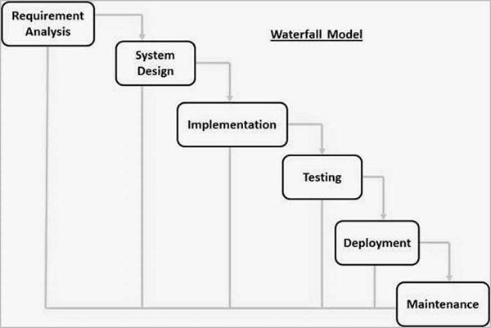

**Figure 4.1. Waterfall Model**

### [RAD Model](https://www.javatpoint.com/software-engineering-rapid-application-development-model)

The Rapid Application Development (RAD) process is an adaptation of the waterfall model that aims to develop software in a short period of time. The RAD model is based on the idea that by using focus groups to gather system requirements, a better system can be developed in less time.

* + - * Business Modeling
      * Data Modeling
      * Process Modeling
      * Application Generation
      * Testing and Turnover

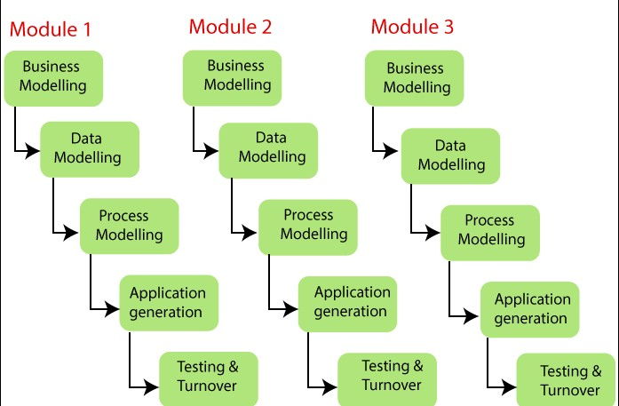

**Figure 4.2. RAD Model**

### [Spiral Model](https://www.javatpoint.com/software-engineering-spiral-model)

The spiral model is a process model that is risk-driven. This SDLC model assists the group in implementing elements of one or more process models such as waterfall, incremental, waterfall, and so on. The spiral technique is a hybrid of rapid prototyping and concurrent design and development. Each spiral cycle begins with the identification of the cycle's objectives, the various alternatives for achieving the goals, and the constraints that exist. This is the cycle's first quadrant (upper-left quadrant).

The cycle then proceeds to evaluate these various alternatives in light of the objectives and constraints. The focus of evaluation in this step is on the project's risk perception.

This step may involve activities such as benchmarking, simulation, and prototyping.

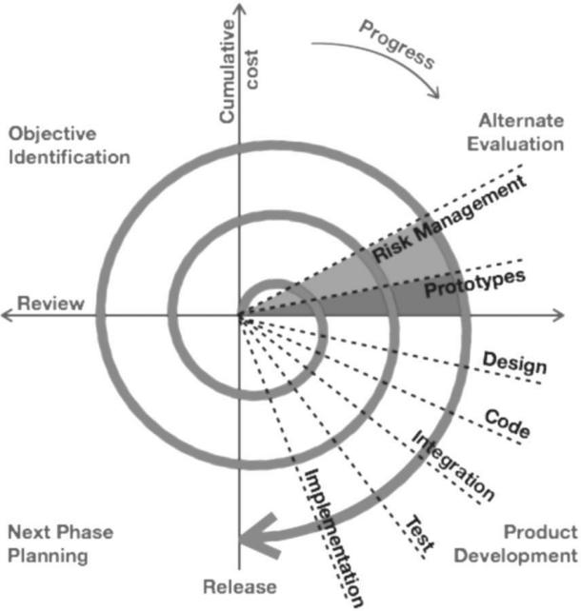

**Figure 4.3. Spiral Model**

### [Incremental Model](https://www.javatpoint.com/software-engineering-incremental-model)

The incremental model does not stand alone. It must be a series of waterfall cycles. At the start of the project, the requirements are divided into groups. The SDLC model is used to develop software for each group. The SDLC process is repeated, with each release introducing new features until all requirements are met. Each cycle in this method serves as the maintenance phase for the previous software release. The incremental model has been modified to allow development cycles to overlap. The following cycle may begin before the previous cycle is completed.

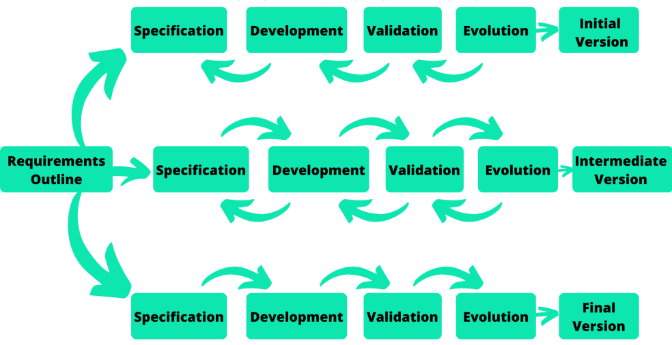

**Figure 4.5. Incremental Model**

## Model used in project: [Agile Model](https://www.javatpoint.com/software-engineering-agile-model)

Agile methodology is a practice that encourages continuous interaction between development and testing throughout any project's SDLC process. The Agile method divides the entire project into small incremental builds. All of these builds are delivered in iterations, with each iteration lasting between one and three weeks. Any agile software phase is defined in such a

way that it addresses several key assumptions about the majority of software projects:

* It's difficult to predict which software requirements will remain constant and which will change. It is also difficult to predict how user priorities will shift as the project progresses.
* Many types of software require both design and development. That is, both activities should be carried out concurrently so that design models can be validated as they are developed. It's difficult to imagine how much design work is required before construction is used to test the configuration.
* Analysis, design, development, and testing are not as predictable as we would like (from a planning standpoint).

The agile software development emphasises on four core values:

1. Individual and team interactions over processes and tools
2. Working software over comprehensive documentation
3. Customer collaboration over contract negotiation

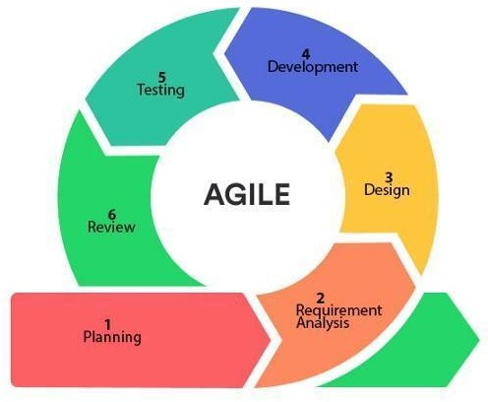

1. Responding to change over following a plan

**Figure 4.8. Agile Model**

**CHAPTER 5**

# APPLICATION ARCHITECTURE

The "QRSAY" project aims to revolutionize food ordering, both online and offline, by providing a user-friendly application. This application offers a comprehensive solution for dine-in, scheduled dining, take-away, and delivery, enhancing convenience and efficiency for both customers and restaurants. Additionally, it may feature AI-driven personalized recommendations and health-conscious menu options. The Application Architecture plays a crucial role in delivering these functionalities.

**5.1 Overall Architecture**

The overall architecture of the "QRSAY" application is designed to cater to various dining scenarios, including dine-in, take-away, and delivery. It comprises the following components:

**5.1.1 Client-Side**

The client-side component focuses on the end-users' experience, providing a user-friendly interface for customers and restaurant staff. This includes:

- Customer Mobile App: Tailored for customers, the mobile app allows them to place orders for dine-in, take-away, and delivery. It offers user-friendly navigation and personalized recommendations based on AI.

- Restaurant Web Interface: Restaurant staff can access a web-based interface for order management, table reservations, and menu updates. This interface is accessible on computers and tablets within the restaurant.

**5.1.2 Server-Side**

The server-side component handles the core functionality of the application, including order processing, recommendation systems, and data storage:

- Frontend Server: This server is responsible for delivering user interfaces to clients and handling client requests. It ensures a seamless user experience using Angular.

- Backend Server: The backend server executes business logic, manages data, and facilitates communication between the frontend and the database. It is developed using Express.js and Node.js.

- Database Server: MongoDB is used as the database management system to efficiently store and retrieve data related to customers, restaurants, orders, and menus.

- AI Server: For personalized recommendations and AI-driven features, a dedicated AI server is employed with a minimum of 16GB RAM and a quad-core CPU to efficiently process AI algorithms.

**5.2 Interaction Flow**

The architectural design defines the flow of interactions within the "QRSAY" application, ensuring that user requests are handled seamlessly. The sequence of interactions for different dining scenarios is as follows:

**5.2.1 Dine-In Order**

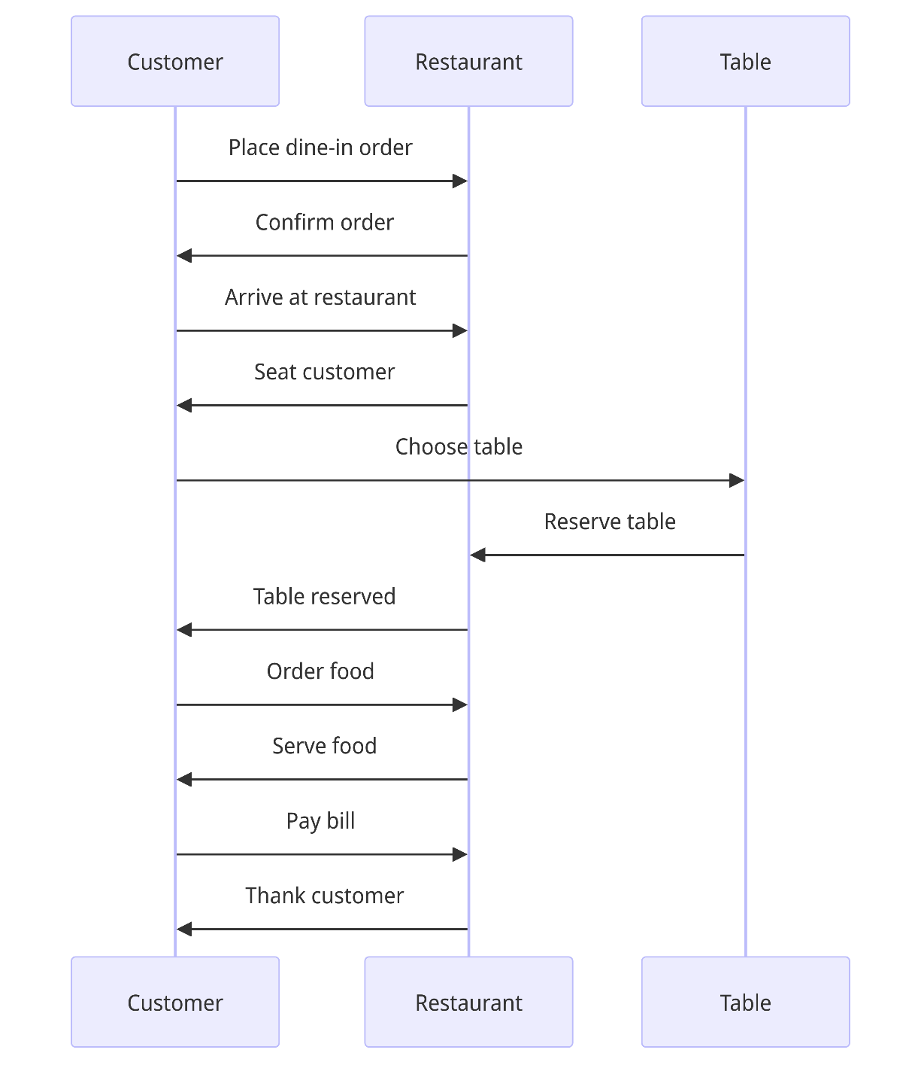

Figure 5.1

1. The customer places a dine-in order through the mobile app.

2. The restaurant confirms the order.

3. Upon arrival at the restaurant, the customer is seated.

4. The customer chooses a table.

5. The table is reserved.

6. The customer places a food order.

7. The restaurant serves the food.

8. The customer pays the bill.

9. The restaurant thanks the customer.

**5.2.2 Take-Away Order**

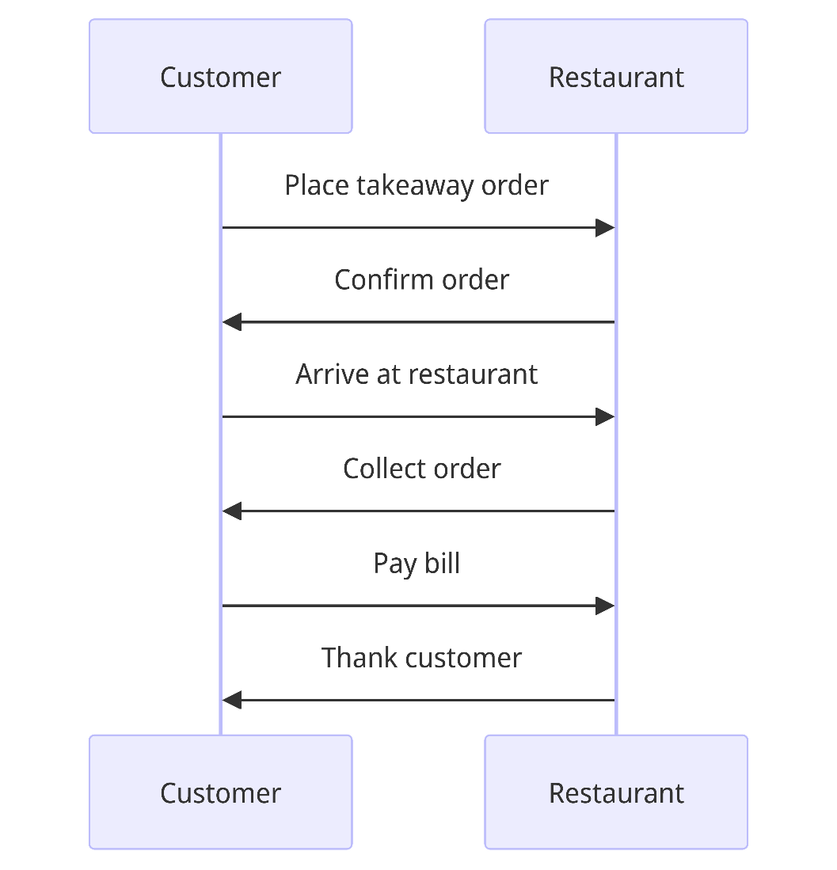

Figure 5.2

1. The customer places a take-away order through the mobile app.

2. The restaurant confirms the order.

3. The customer arrives at the restaurant.

4. The order is collected.

5. The customer pays the bill.

6. The restaurant thanks the customer.

**5.2.3 Delivery Order**

1. The customer places a delivery order through the mobile app.

2. The restaurant confirms the order.

3. The customer provides a delivery address.

4. The restaurant assigns a delivery person.

5. The delivery person collects the order.

6. The restaurant hands over the order.

7. The delivery person delivers the order.

8. The customer pays the bill.

9. The delivery person thanks the customer.

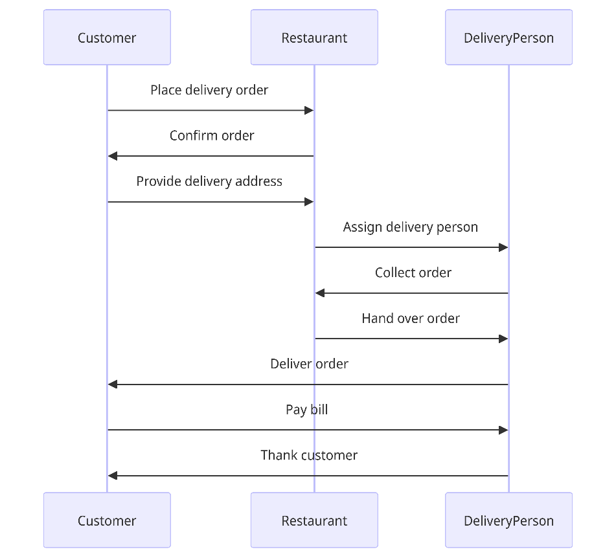

Figure 5.3

**5.3 Security Measures**

Security measures are implemented throughout the application architecture to protect user data and financial transactions. These measures include:

- Data Encryption: Sensitive information is encrypted to ensure privacy and security.

- User Authentication: Robust user authentication mechanisms are in place to protect user accounts and data.

- Secure Payment Processing: Industry-standard APIs are integrated to ensure safe and efficient financial transactions.

**5.4 Scalability and Performance**

The architecture is designed to handle potential growth in user demands while maintaining optimal performance:

- Dedicated web servers with ample resources ensure scalability.

- Efficient coding practices and the use of the MEAN stack contribute to performance.

- Frequent testing and optimization address performance bottlenecks.

**5.5 System Integration**

The application integrates with external systems to enhance functionality, including secure payment processing.The Application Architecture of the "QRSAY" project lays a strong foundation for offering a user-centric and efficient food ordering experience, catering to diverse dining scenarios.

**5.6 ER Diagram**

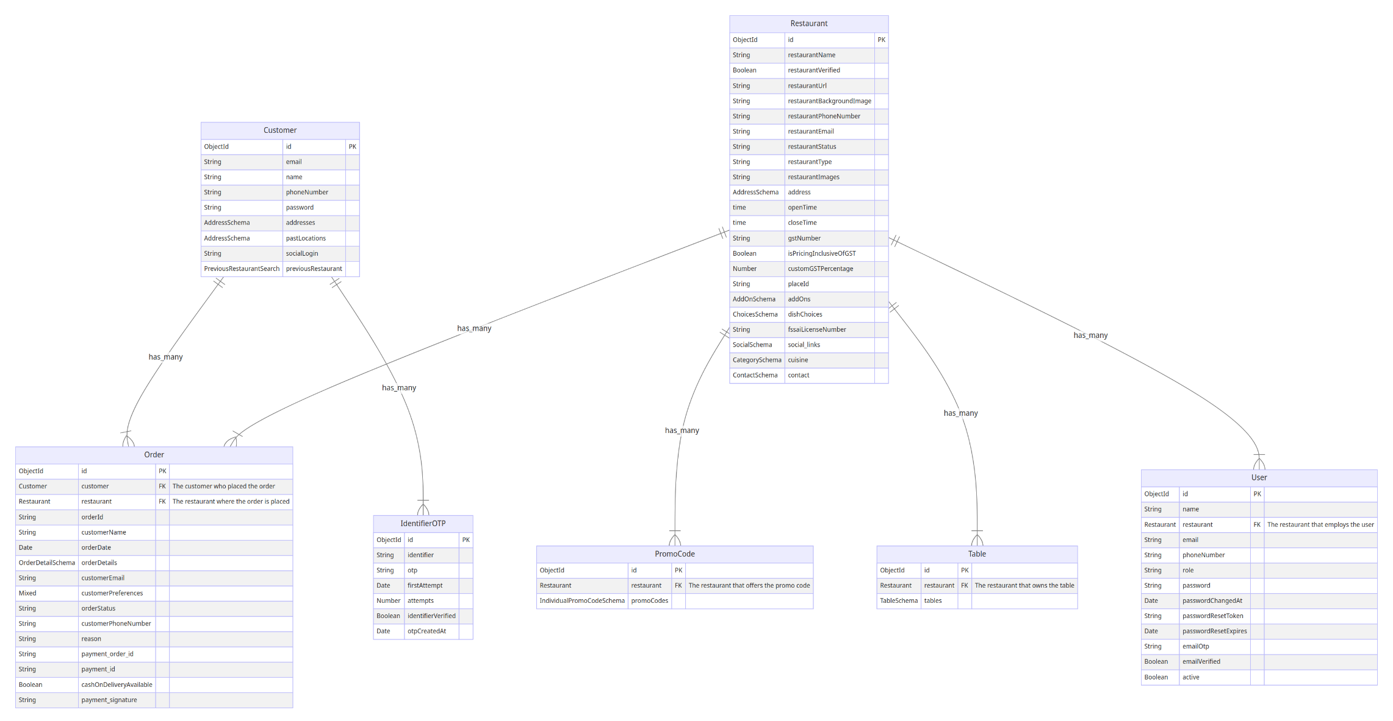

# References

1. Shroff, A., Shah, B. J., & Gajjar, H. (2022). Online food delivery research: a systematic literature review. International Journal of Information Systems and Project Management, 10(1), 5-28.
2. Bonfanti, A., Rossato, C., Vigolo, V., & Vargas-Sánchez, A. (2023). Improving online food ordering and delivery service quality by managing customer expectations: evidence from Italy. Journal of Service Theory and Practice, 33(1), 123-145.
3. Esposito, B., Sessa, M. R., Sica, D., & Malandrino, O. (2022). Service innovation in the restaurant sector during COVID-19: digital technologies to reduce customers’ risk perception. The TQM Journal, 34(7), 1049-1070.
4. Resham Shinde, Priyanka Thakare, Neha Dhomne, Sushmita Sarkar, ”Design and Implementation of Digital dining in Restaurants using Android”, International Journal of Advance Research in Computer Science and Management Studies 2014.
5. Ashutosh Bhargave, Niranjan Jadhav, Apurva Joshi, Prachi Oke, S. R Lahane,“Digital Ordering System for Restaurant Using Android”, International Journal of Scientific and Research Publications 2013.
6. Khairunnisa K., Ayob J., Mohd. Helmy A. Wahab, M. Erdi Ayob, M. Izwan Ayob, M. Afif Ayob, ”The Application of Wireless Food Ordering System” MASAUM Journal of Computing 2009.
7. Noor Azah Samsudin, Shamsul Kamal Ahmad Khalid, Mohd Fikry Akmal Mohd Kohar, Zulkifli Senin, Mohd Nor Ihkasan,” A customizable wireless food ordering system with real time customer feedback”, IEEE Symposium on Wireless Technology and Applications(ISWTA) 2011.